Guideline For Action Hologram

Made By @christsaragih

1. In new scene please add prefabs Game Object “Camera Actiongram” and “HandsTracking” on **Holo Actiongram\Assets\Application\Prefarbs\ActionGramCamera** to the scene.

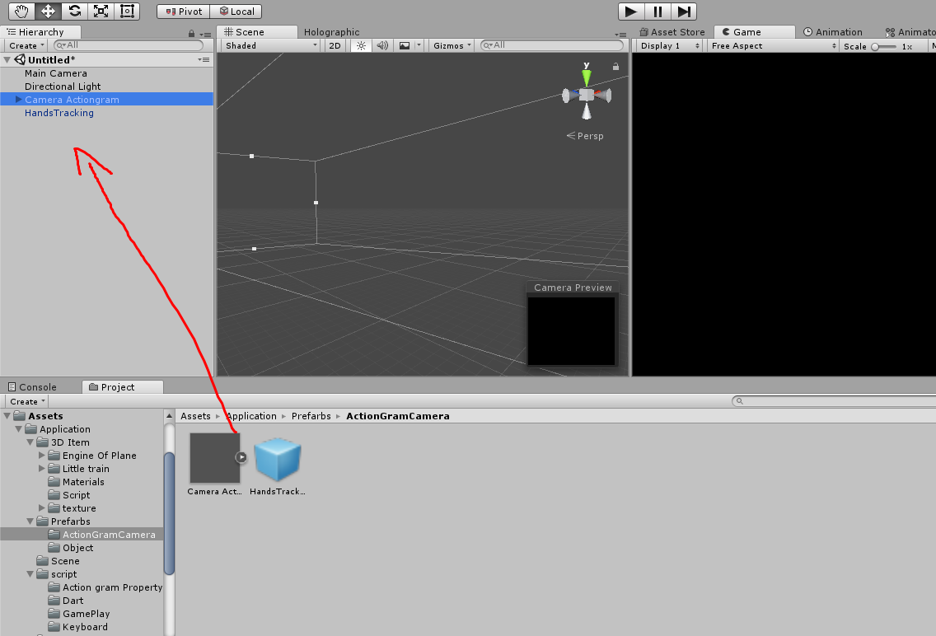

1. Add prefabs Spatial Maping To scene on **Holo Actiongram\Assets\Holograms**

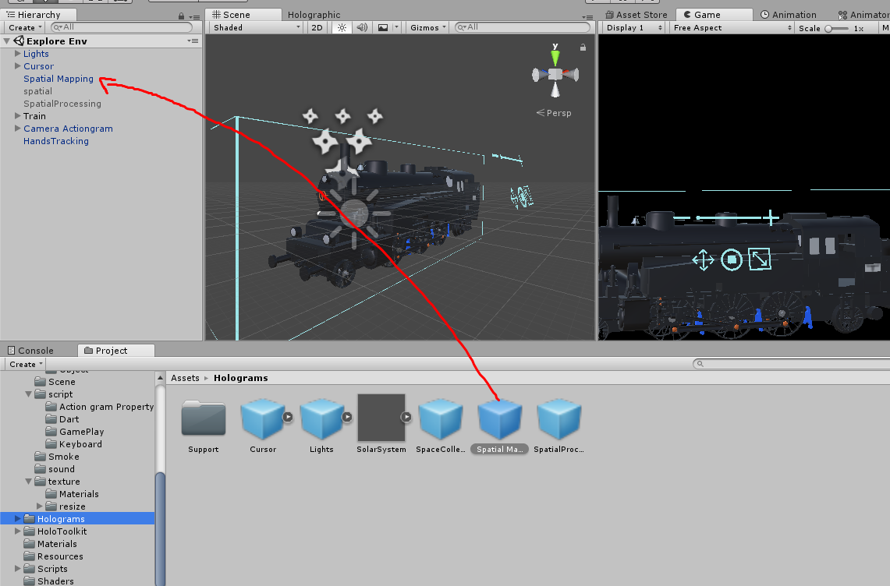

1. On Scene add **Simple Action Holo** Prefabs to scene **Holo Actiongram \ Assets \Application\Prefarbs\Object**

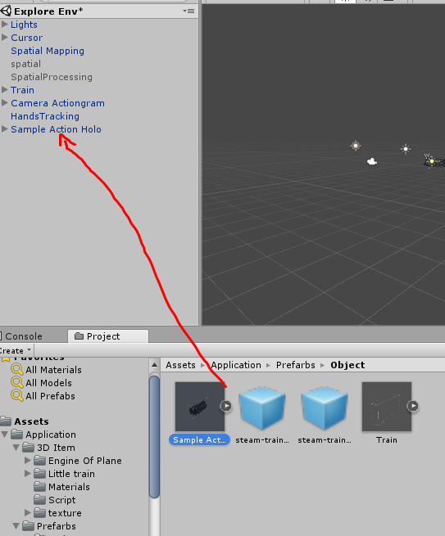

1. Replace 3d Model on **sample action holo**

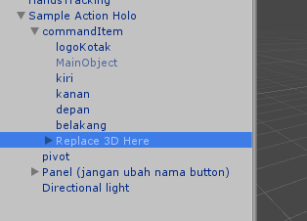

1. Before replace 3d makesure LogoKotak have same size with the 3D object, u can resize on commandItem.
2. Enjoy the template.

If u have any question u can contact me at [saragihchristian@gmail.com](mailto:saragihchristian@gmail.com)